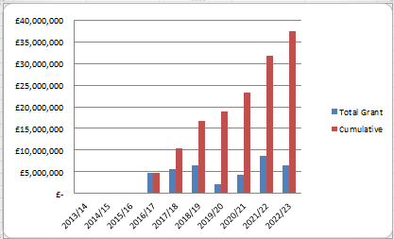
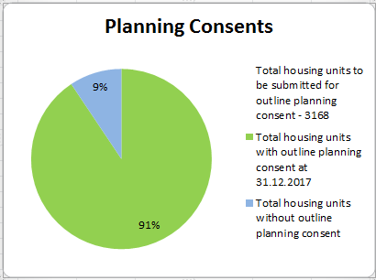
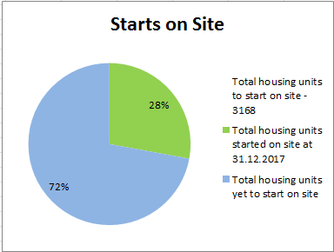
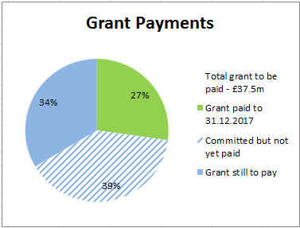
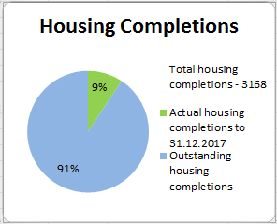
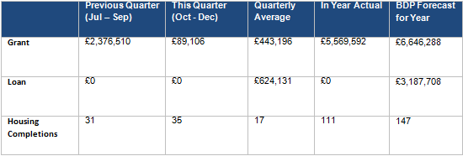
No additional planning permission for residential development secured by HCA in this reporting period.

Only Pickerings Farm is yet to achieve planning, however an amended planning consent for remaining Whittingham phases is required.
Residential development is underway on five outlets. There has been a slight increase in housing completions to reflect the increased development activity on Cottam Hall, Eastway, Whittingham and Croston Road South.
No additional Starts on Site during this reporting period.

Starts on Site are counted for the entire site on commencement of first unit.

£89,106 of grant paid in this reporting period. The grant was lower this quarter due to no contractual payments being due from developers and there were no new disposals this quarter. The grant payments relate to 3 plot sales at Cottam Site K.

1.0 Report Overview

  - This report provides an update on the progress made by Homes England on the delivery of the City Deal housing sites from 01.09.17 to 31.12.17. It focuses on the key delivery milestones, finances invested, outputs and draws out key risks and emerging issues.

2.0 Recommendation

  - The Stewardship Board and Executive are recommended to:

    - Note the content of the report and the progress made

- Homes England Site Highlights (01.10.17 to 31.12.17)

  - Between the period 01.10.17 and 31.12.17, progress has been made on a number of Homes England sites. Key highlights and future milestones can be found in the table below:

Site | Project | Status | Completions/  total units | Completions (Oct - Dec) | Finance  (Oct - Dec) | Summary | Milestones for next quarter (Jan - Mar)
1 | Cottam Hall Phase 1 (Site K) | Barratts on site | 79/104 (76%) | 5 | £89,106 grant paid to LCC in this reporting period | There have been 5 further completions this reporting period and one additional completion since the end of the reporting period.  The grant consisted of payments from 3 plot sales. | A final grant payment of £113,597 will be paid to LCC in February 2018. Barratts will have then paid for the site in full and LCC will have received the entire grant for this site.
1 | Cottam Hall Phase 2 | Story Homes on site. | 33/283 (12%) | 3 | N/A | Storys Homes building out well. | N/A – ongoing build out
1 | Cottam Hall Phase 3 | Deal done with Morris Homes - not yet on site. RM application deferred until March 18. | 0/119 (0%) | N/A | N/A | Preston CC planning committee considered the RM application in January and the application was deferred. The earliest next committee will be 8th March. This has resulted in a loan payment of £3.9m forecast for March 2018 slipping to next financial year. | RM application to go to March planning committee. The deal is anticipated to go unconditional in May once JR period has expired. This will trigger the loan payment (£3.9m)
2 | Cottam Brickworks | Planning permission in place | 0/206 (0%) | N/A | N/A | Site in 3rd party ownership. Access land agreement has lapsed. | No progress envisaged by land owner in forthcoming quarter.
3 | Land at Eastway (resi) | Story Homes on site. | 19/300 (6%) | 5 | N/A | There has been one further completion since the end of the reporting period.  Since the end of the reporting period a grant payment of £16,731 was made to LCC relating to an overage payment made by Story Homes to Homes England. | Grant payment of £16,731 to be paid to LCC in January 2018 (paid)
3 | Land at Eastway (commercial) | Conditional contracts exchanged with HBS Healthcare Ltd – not yet on site. | N/A (commercial) | N/A | N/A | Contracts were exchanged with HBS Healthcare Ltd in May on a conditional basis – the condition is that Story Homes construct the access to the site and that HBS secure RM planning consent. Story Homes now have planning consent for the access road and changes to the guild wheel. HBS has submitted a planning application for the site. The programme for access works delivery is a start in mid-2018 with October completion. The position therefore is the unconditional sale and land receipt (followed by subsequent loan and grant payment to LCC) will be Oct 2018 and not this financial year. | S278 to have been drawn up.
4 | Whittingham | Taylor Wimpey on site (phase 1 only) | Ph 1 - 66/150 (44%) | 7 | N/A | Consultant procurement to resolve planning and design issues has resulted in a team including Campbell Reith, Barton Willmore, and JLL being appointed to develop a planning and disposal strategy | Consultation on masterplan options, planning strategy and highways to have taken place.  Meetings with PCC and LCC to take place in February 2018. Meeting with sports and social club to take place by the end of March.
5 | Preston East EA | Site not yet marketed | N/A (commercial) | N/A | N/A | Soft marketing test has been completed. There is a very good range of interest in the site. There is a very good market for these types of sites currently.  The disposal options appraisal work has also been completed with JLL and we have preferred option which Homes England will be bringing an internal approval paper forward for in the coming months. It is anticipated that the site would be out to the market in c9 months’ time. | N/A
5 | Preston East – Sector D | Deal completed with Inchcape Estates – now on site | N/A | N/A | N/A | Inchscape Estates have secured planning permission and are now on site | N/A
6 | Pickerings Farm | Site not yet marketed | 0/297 (0%) | N/A | N/A | Negotiations with Taylor Wimpey re collaboration agreement progressing well. Both parties have agreed 90% of the Collaboration Agreement terms and Homes England now need to secure Director of Land support to the terms which involves a future acquisition of land by Homes England from TW. | Internal approval to be secured for Collaboration Agreement (target is by end of Fed  Homes England to then instruct consultants on masterplan and planning and engage with SRBC and other stakeholders.
7 | Altcar Lane | Site currently on the market | 0/200 (0%) | N/A | N/A | Internal approval was secured on 22 Jan to proceed with the preferred bidder (Lovell).  Conditional contracts are due to be in place by March 2018. They start on site Jan 19 and, as this is an Accelerated Construction project, receipt will be paid upon completion of the last unit in Jan 2022. | Contracts should be in place with Lovell
8 | Croston Road North | Site not yet marketed | 0/400 (0%) | N/A | N/A | Phase 1 now agreed with South Ribble. HCA due to start marketing this phase in April 2018. Progress has been made on the acquisition of land currently outside of HCA ownership, which if successful will enable the completion of the spine road. | N/A
9 | Croston Road South | Miller on site. | 53/175 (30%) | 13 | N/A | Millers on site and building out. Very strong sales evidence.  There have been 3 further completions since the end of the reporting period. | N/A – ongoing build
10 | Brindle Road | Complete | 46/46 (100%) | N/A | N/A | All units completed and all finances resolved. | N/A
11 | Walton Park Link | Morris on site | 0/350 (0%) | N/A | N/A | Deal between Morris Homes and National Grid has now gone unconditional. Morris commenced early site clearance works on site in September. | N/A – ongoing build

4.0 Housing Infrastructure Fund (HIF)

4.1 Since the end of the reporting period, the outcome of the Marginal Viability HIF bids have been announced, for which LCC had submitted a bid for Pickerings Farm. The Pickerings Farm bid was not successful, however Homes England will be reviewing all unsuccessful HIF bids to identify where it can best support the most deliverable proposals. The outcome of the Forward Fund HIF bids, for which LCC have also submitted a bid, is likely to be announced in March 2018.

5.0 Risks

5.1 Ongoing delays associated with Pickerings Farm and Whittingham Hospital risk the ongoing success of housing delivery across HCA land. Measures are being put in place to address the delays and expedite progress where possible. There has been progress on Whittingham Hospital with the appointment of a multi-disciplinary team.

5.2 Viability remains a concern at Whittingham Hospital due to the level of abnormal costs associated with a new spine road, foul sewer connection and the provision of a new sports facility. Partners will be engaged in these discussions at the earliest opportunity.

6.0 Summary

6.1 Overall positive progress is being made across the portfolio. The 35 completions last quarter were significantly higher than the quarterly average. Other particular successes include:

- Altcar Lane – a preferred developer has now been selected and the conditional contract should be in place by March 2018.
- Whittingham – the consultant procurement has completed and work is now underway on the development of masterplan options and the planning strategy.
Housing activity should increase over the course of the coming 12 months with a start on site expected at Altcar Lane and Cottam Hall Phase 3. Marketing will also get underway at Croston Road North Ph1.

6.2 HCA are on track to pay the £37.5m grant by 2022/23.


